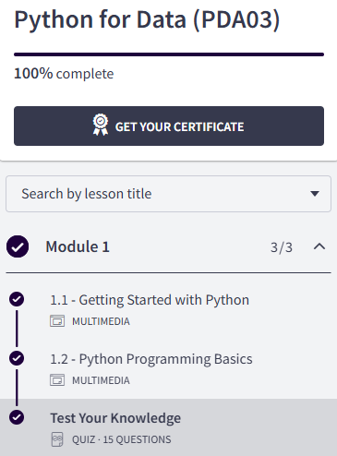
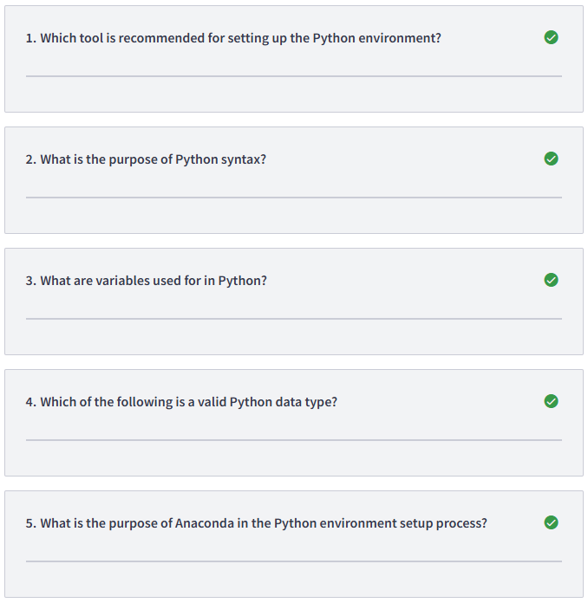
1/ Anaconda
2/ To communicate with the computer
3/ To store data
4/ All of the above: Float, Character, String
5/ To manage packages and environments
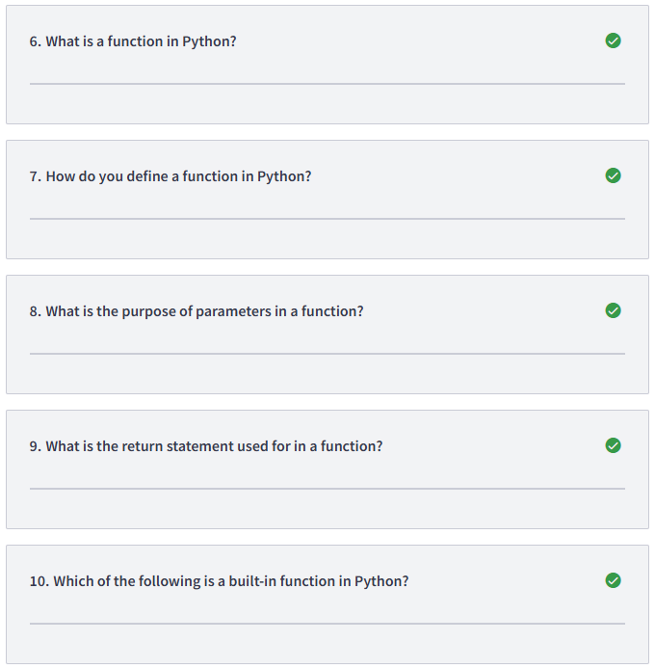
6/ A piece of code that performs a specific task
7/ Using the keyword def
8/ To specify inputs to the function
9/ To return a value from the function
10/ print()
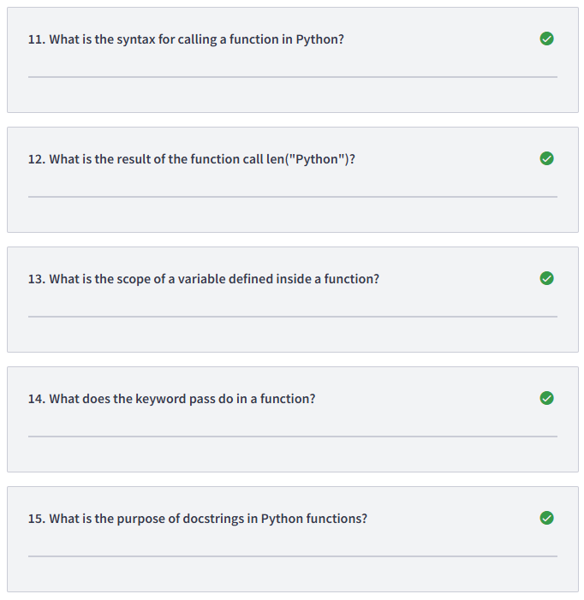
11/ function_name()
12/ 6
13/ Local to the function
14/ Indicates an empty block of code
15/ To document the function's behaviour

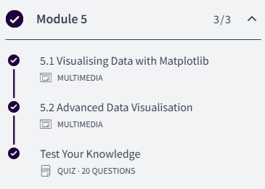
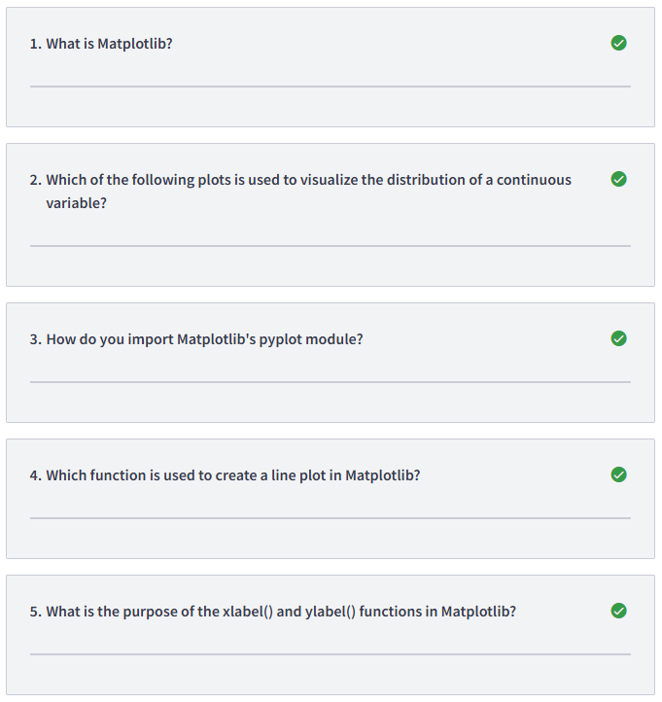
1/ A library for creating visualizations in Python
2/ Histogram
3/ import matplotlib.pyplot as plt
4/ plot()
5/ To label the x-axis and y-axis, respectively
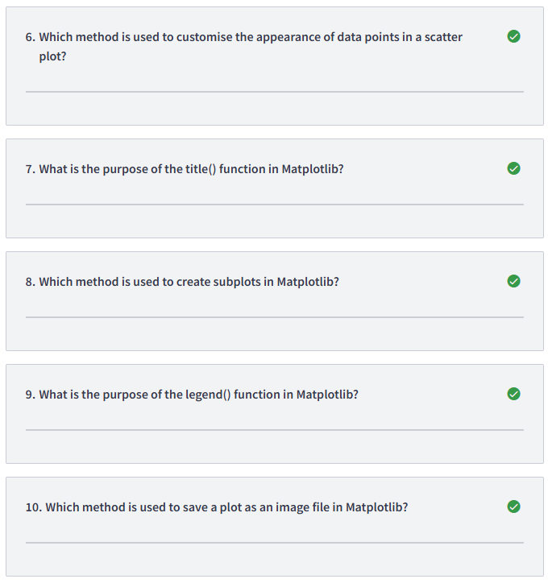
6/ scatter()
7/ To set the title of the plot
8/ subplots()
9/ To create a legend for the plot
10/ savefig()
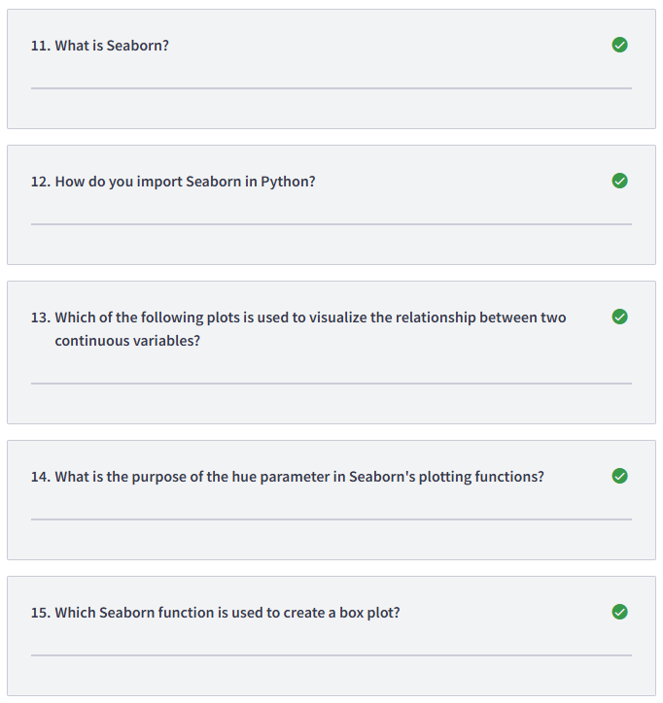
11/ A library for statistical data visualization
12/ import seaborn as sns
13/ Scatter plot
14/ To add a legend based on a categorical variable
15/ boxplot()
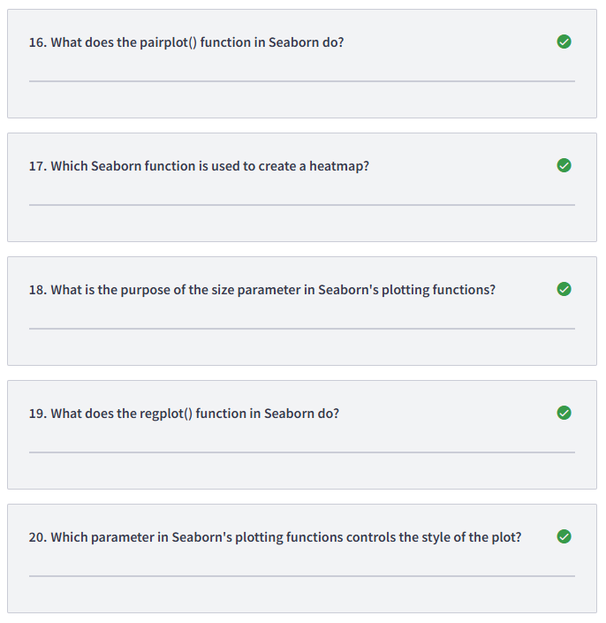
16/ Creates a matrix of scatter plots for each pair of variables in a dataset
17/ heatmap()
18/ To control the size of elements in the plot, such as points or lines
19/ Creates a scatter plot with a regression line
20/ style
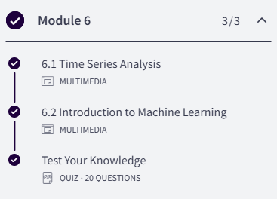
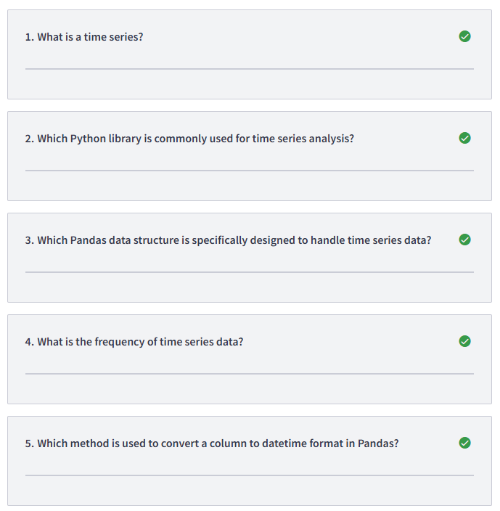
1/ A series of data points indexed in time order
2/ Pandas
3/ Series
4/ The intervals at which the data is collected
5/ to_datetime()
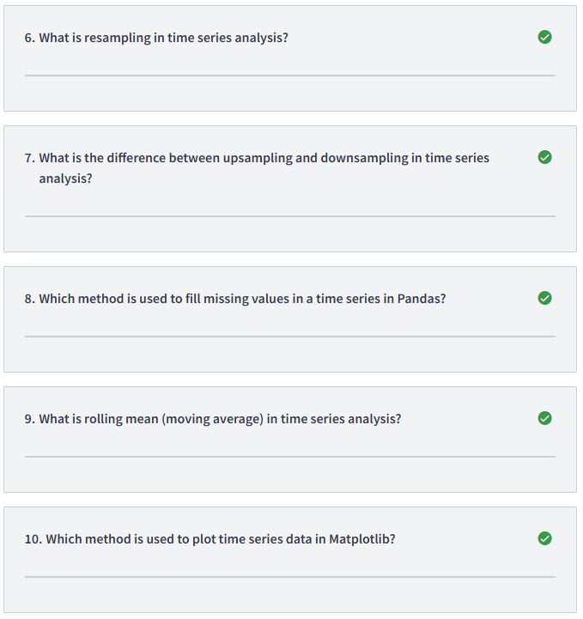
6/ Converting a time series to a different frequency
7/ Upsampling increases the frequency of the data, while downsampling decreases it
8/ fillna()
9/ A statistical technique to smooth out fluctuations in data by taking the average of a fixed-size window of data points
10/ plot()
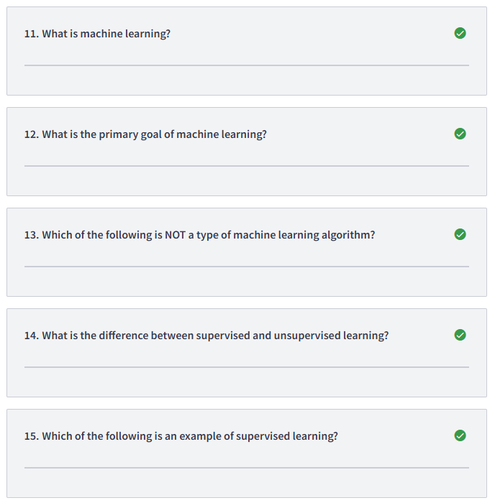
11/ A branch of artificial intelligence focused on training machines to learn from data
12/ To make predictions or decisions based on data
13/ Deterministic learning
14/ In supervised learning, the model learns from labelled data, while in unsupervised learning, the model learns from unlabeled data
15/ Classification
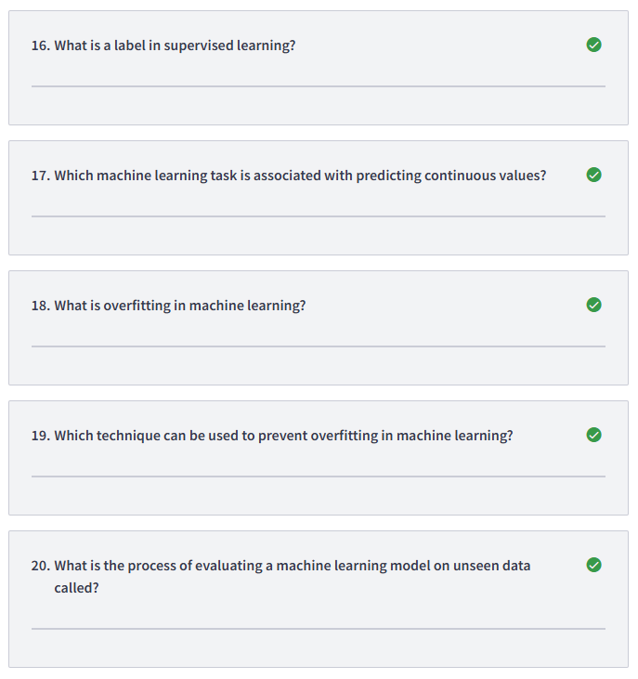
16/ The output or prediction that the model is trying to learn
17/ Regression
18/ When the model performs well on the training data but fails to generalise to new data
19/ Regularisation
20/ Testing
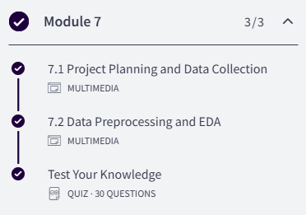
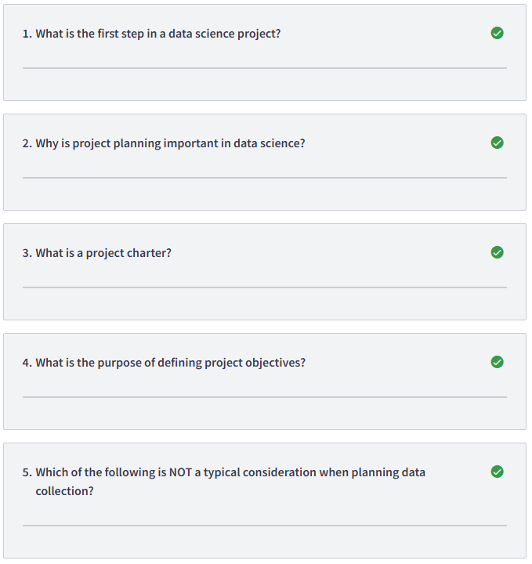
1/ Project planning
2/ It helps define the scope and objectives of the project, it ensures the efficient use of resources, it helps identify potential risks and challenges
3/ A document outlining the project's goals, scope, and stakeholders
4/ To clarify what the project aims to achieve
5/ Choosing machine learning models
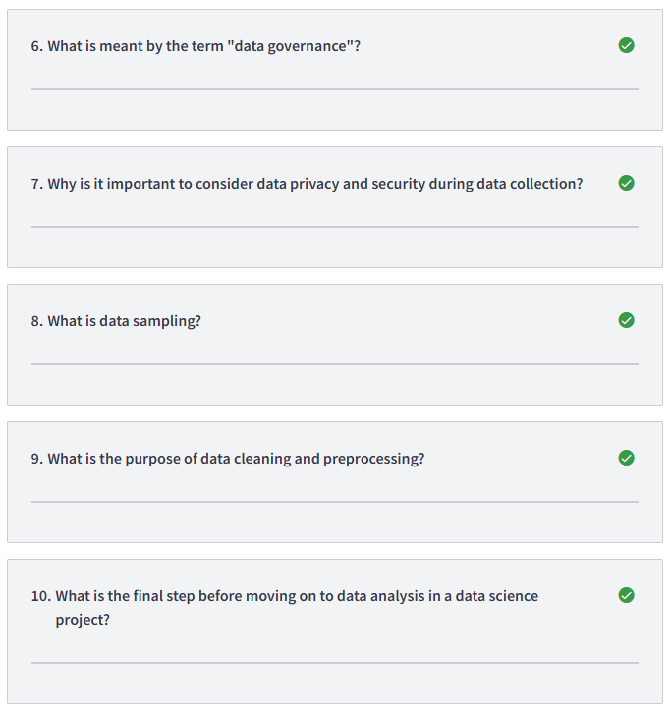
6/ The process of ensuring data quality, security, and compliance
7/ To comply with legal regulations and protect sensitive information
8/ The process of selecting a subset of data from a larger dataset
9/ To remove outliers from the data, to handle missing values, to standardise data formats
10/ Data cleaning and preprocessing
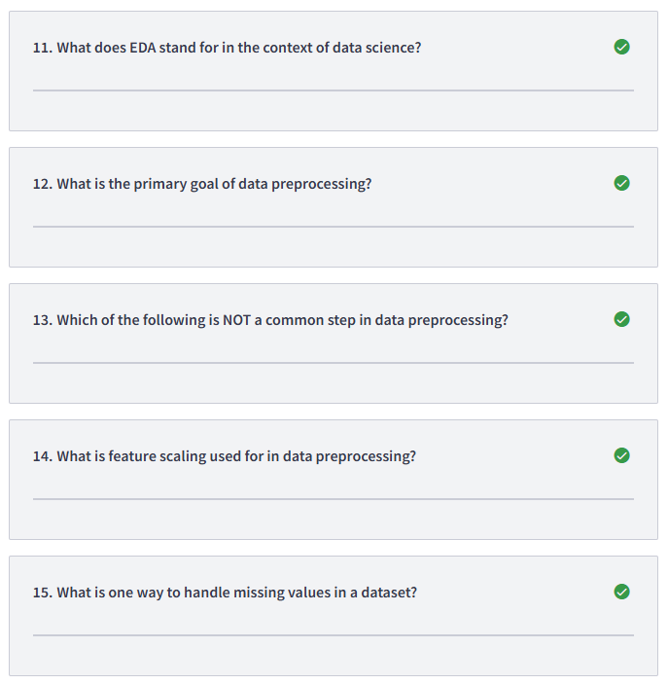
11/ Exploratory Data Analysis
12/ To prepare the data for machine learning algorithms
13/ Data visualisation
14/ To standardize or normalize the range of numerical features
15/ Remove rows with missing values, replace missing values with the mean or median of the column, replace missing values with zeros
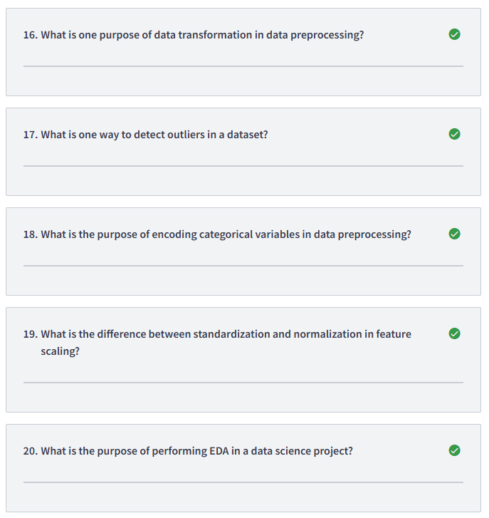
16/ To convert categorical variables into numerical variables
17/ Statistical methods such as z-score or IQR
18/ To convert categorical variables into a format that can be used for machine learning algorithms
19/ Standardization scales the data to have a mean of 0 and a standard deviation of 1, while normalization scales the data to a range between 0 and 1
20/ To visualize the data and understand its characteristics
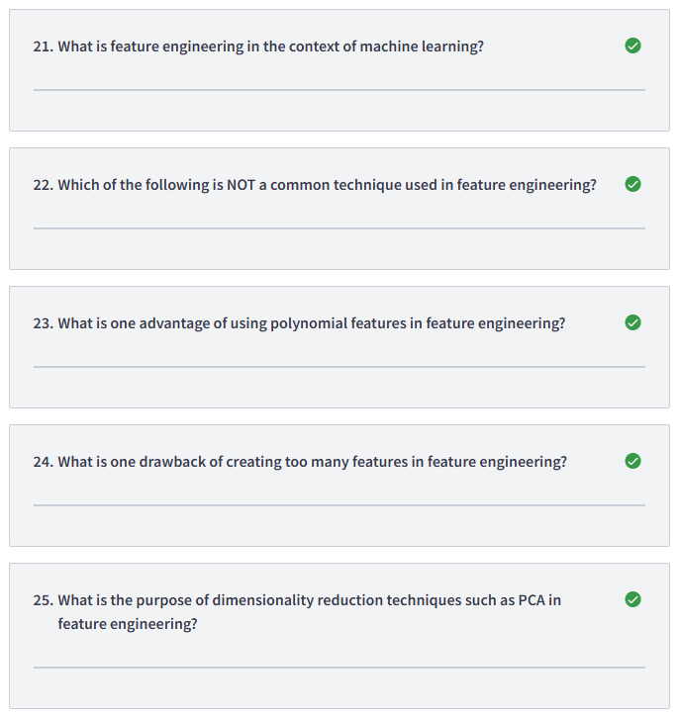
21/ The process of creating new features or modifying existing features to improve model performance
22/ Standardization is not ; One-Hot Encoding, Principal Component Analysis (PCA) and Polynomial Features are
23/ It captures non-linear relationships between features
24/ It increases the computational complexity of the model
25/ To reduce the number of features while preserving important information
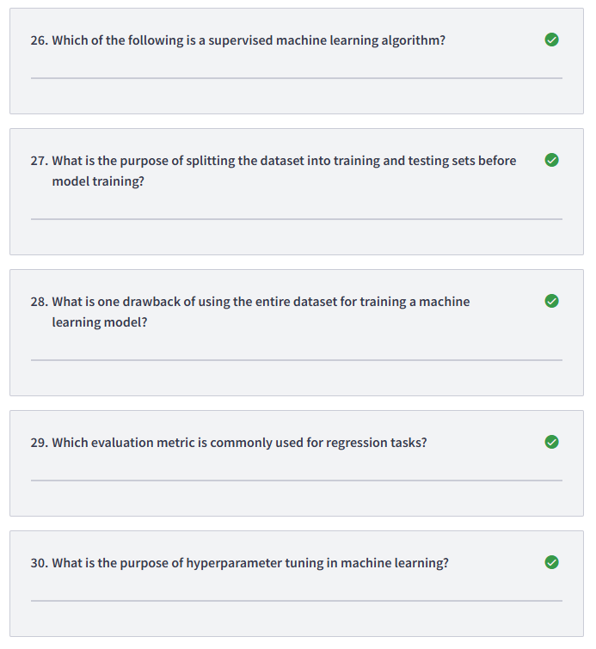
26/ Linear Regression
27/ To evaluate the performance of the model on unseen data
28/ It leads to overfitting
29/ Mean Squared Error (MSE)
30/ To select the optimal parameters for the model

